EXP: 15

Problem 1: Allow a User to create session
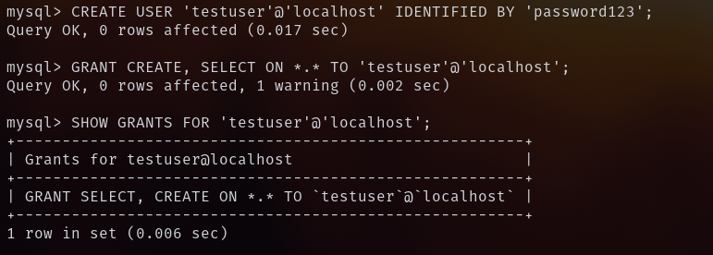
Problem 2: Allow a User to create table
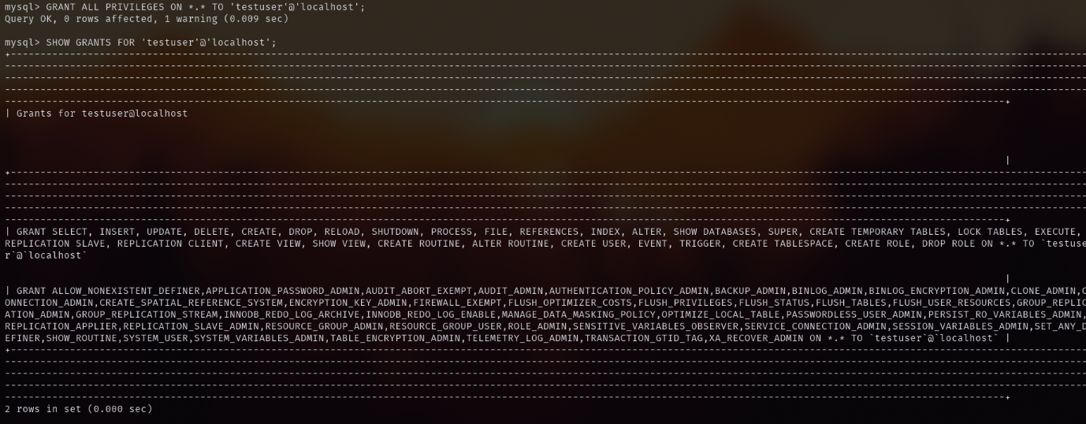
Problem 3: Provide user with space on tablespace to store table
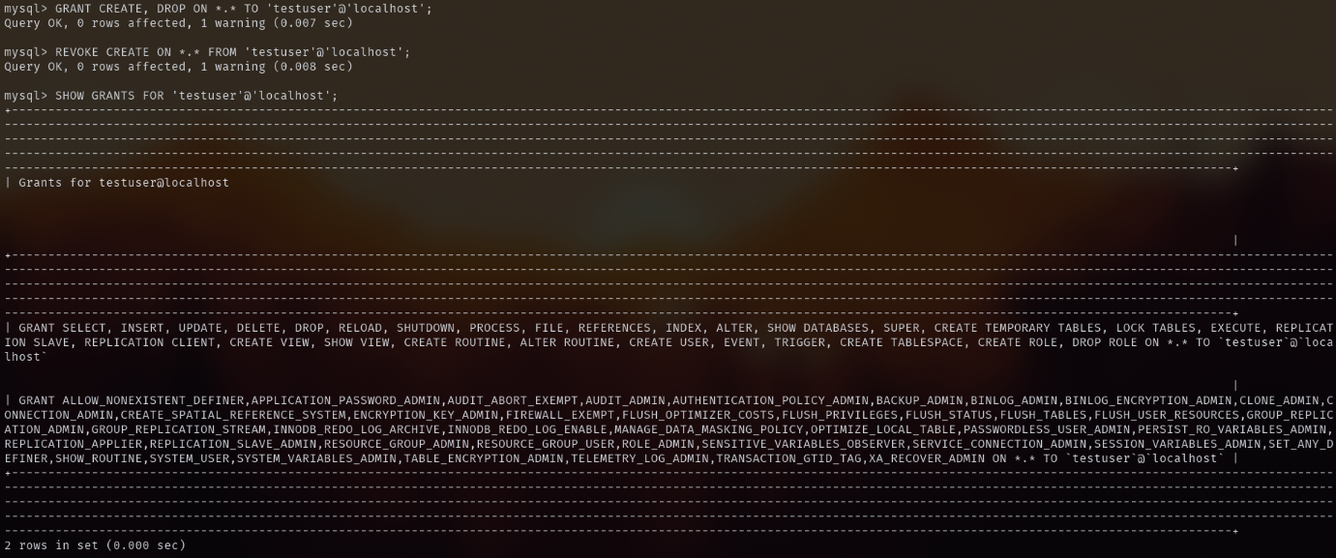
Problem 4: Grant all privilege to a User
